**INTI International College Penang School of Engineering and Technology**

**3+0 Bachelor of Science (Hons) in Computer Science, in collaboration with Coventry University, UK**

**3+0 Bachelor of Science (Hons) in Computing, in collaboration with Coventry University, UK**

**Coursework cover sheet**

**Section A - To be completed by the student**

|  |  |
| --- | --- |
| Full Name:KHOR WEI MIN | |
| CU Student ID Number:p22014754 | |
| Semester:YEAR 1 SEMESTER 1 | |
| Session:  **August 2022** | |
| Lecturer:  **Nadhrah Abdul Hadi (nadhrah.abdulhadi@newinti.edu.my)** | |
| Module Code and Title:  **4067CEM Software Design** | |
| Assignment No. / Title:  **Continuous Assessment** | % of Module Mark:  **50** |
| Hand out Date:  **6th September 2022** | Due Date:  **Task 1: 30 September 2022, by 11.59pm.**  **Task 2: 18 November 2022, by 11.59pm**  **Task 3: 4 November 2022, by 11.59pm.**  **Task 4: 4 November 2022, by 11.59pm.**  **Task 5: 4 November 2022, by 11.59pm.** |
| Penalties: No late work will be accepted. If you are unable to submit coursework on time due to extenuating circumstances, you may be eligible for an extension. Please consult the lecturer. | |
| Declaration: I/we the undersigned confirm that I/we have read and agree to abide by the University regulations on plagiarism and cheating and Faculty coursework policies and procedures. I/we confirm that this piece of work is my/our own. I/we consent to appropriate storage of our work for plagiarism checking.  Signature(s): ___________MIN_____________ | |

**Section B - To be completed by the module leader**

|  |  |  |
| --- | --- | --- |
| Intended learning outcomes assessed by this work:  1. Understand and apply appropriate concepts, tools and techniques to each stage of the software development  2. Understand and apply design patterns to software components in developing new software  3. Demonstrate an understanding of project planning and working to agreed deadlines, along with professional, interpersonal skills and effective communication required for software production  5. Demonstrate an awareness of, and ability to apply, social, professional, legal and ethical standards as documented in relevant laws and professional codes of conduct such as that of the Malaysian National Computer Confederation. | | |
| Marking scheme | Max | Mark |
| 1. User Story Mapping 2. Setting up a GitHub Repository 3. Creating a Class diagram and design pattern selection 4. Creating a Prototype User Interface and Usability Testing 5. Discuss the ethical issue related to the software | 20  10  30  20  20 |  |
| Total | 100 |  |

Class diagram

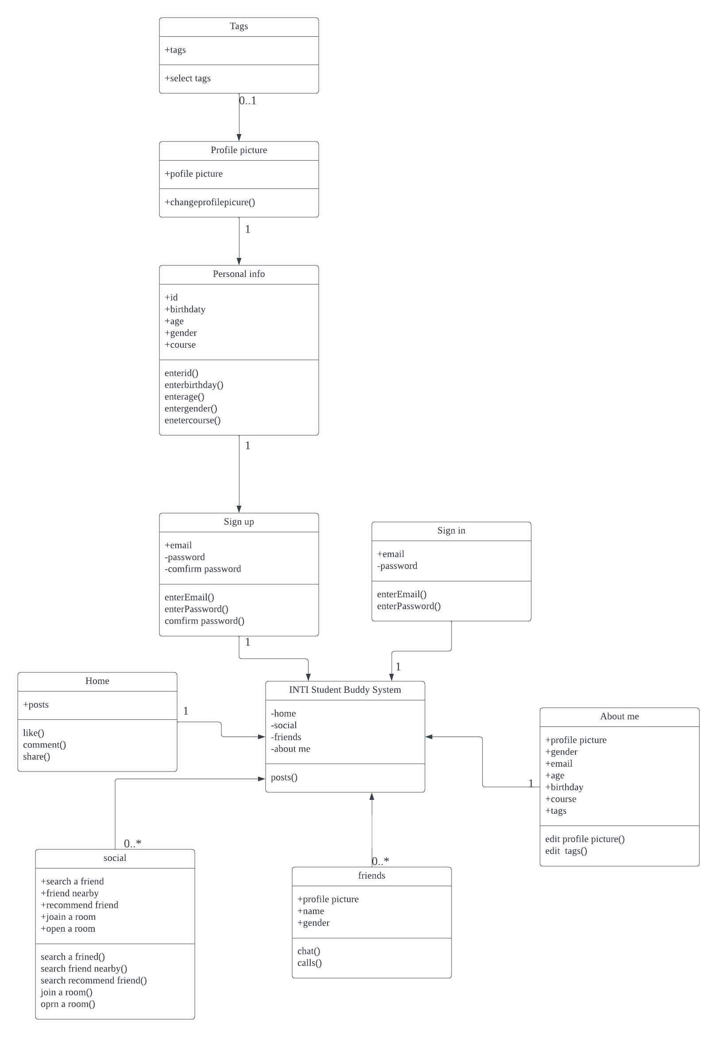

Uml diagram

